Business Project

●Detail of Business:

○Corporate name: Online Pet doctor

○Address: SCNU

○telephone number: 13660879926

●Detail of the Group:  
 ○Project Contributors:

**Table 1: Members of the group and Students’ID**

|  |  |
| --- | --- |
| **Name** | **Students’ID** |
| Zhuohang DU | 20213803034 |
| Keyao Li  Xijin Huang | 20213803020  20213802050 |
| Zhongzheng Bao | 20213802052 |

○Date of Submission:

# Contents

**1.Excutive Summary ...............................................................................................................................2**

1.1 Brief Description of Business .....................................................................................................2

1.2 About app ....................................................................................................................................3

1.3 Target Market...............................................................................................................................3

**2.The Business ......................................................................................................................................... 3**

2.1 Market Analysis...........................................................................................................................3

2.1.1 Porters Competitive Forces Model...................................................................................3

2.1.2 SWOT Analysis.................................................................................................................5

2.1.3 User Persona…………………………………………………………………………….6

**3.Business Operations .............................................................................................................................6**

3.1 Business Model ...........................................................................................................................6

3.2 Marketing Strategies....................................................................................................................6

**4.App Validation ....................................................................................................................................7**

4.1Key tests and principles .............................................................................................................7

**1.Excutive Summary**

**1.1 Description of the Business**

We are a team of data science and artificial intelligence from South China Normal University Aberdeen, aiming to provide users with more convenient pet medical services. Our team is composed of many college students with rich experience and professional skills.

All our team members are responsible for the development and maintenance of our Pet Doctor App. We are proficient in a variety of technologies and programming languages, capable of developing software applications and ensuring user experience through updates. Students majoring in information management understand market trends and user needs, and can develop feasible marketing strategies and plans to attract users and promote our App through various channels.

We are committed to providing users with high-quality, safe and convenient pet family doctor services. We will continue to improve and refine our Family Doctor App to meet the changing needs and expectations of our users.

**1.2 About app**

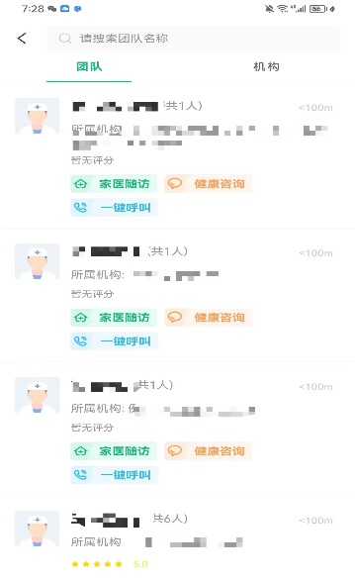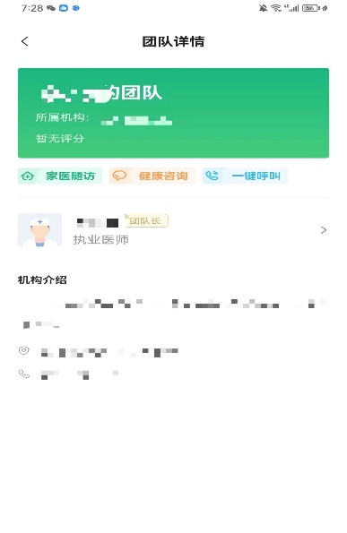

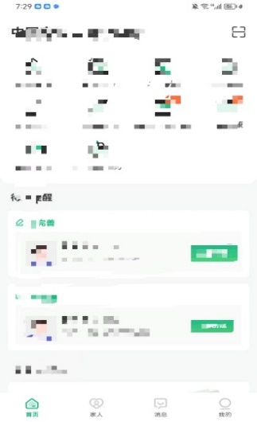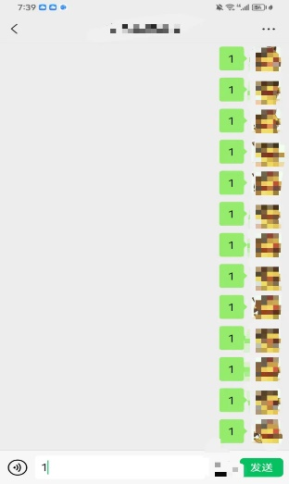

While using our app, customers are able to

1. Chose different medical groups which they may think is suitable for their problem
2. Have a detail overview of the information of groups
3. Communicate with our doctors and be informed when doctors reply
4. Navigate to different services which we will put forward sooner

# 1.3 Target Market

The pet Doctor app of our team is mainly targeted at pet owners, especially those who are loving, care about pet health, and are willing to spend time and money to take care of their pets. According to the data, the global pet market scale has exceeded 100 billion dollars, and has been growing year by year, which provides a good market opportunity for this software.

# 2 The Business

# 2.1 Market Analysis

**2.1.1 Porters Competitive Forces Model**

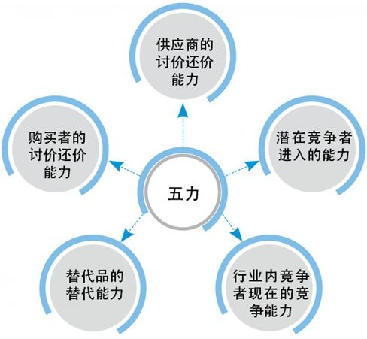

**●The current competitiveness of competitors in the industry**

Competition between enterprises is the direct confrontation between enterprises in an industry. It is often the most important of the five forces. Currently, the most influential online medical platforms are Dingxiang Doctor and Baidu's Baidu Health. However, their main strategic direction is the online medical treatment for people. Therefore, the online medical platform market for pets is still relatively vacant at present, and the prospect of this direction is quite ideal.

**●The competitiveness of potential competitors**

With the improvement of people's living quality, the gap in the pet market will become larger and larger. Therefore, the demand of related industries, such as the pet medical industry, will increase, and the future market scale will increase the competitiveness of potential competitors.

**●Bargaining power of suppliers**

Suppliers of online pet medical platform are doctors with veterinary qualifications and suppliers of pet medical equipment. Currently, the purchase rate of veterinary medicine and equipment on major e-commerce platforms is not high. A highly integrated platform will bring huge benefits to suppliers, so the bargaining power of suppliers is not high.

**●Bargaining power of buyers**

The buyers of the online pet medical platform are families with pet health problems. For these buyers, the need to solve the pet health problems without leaving the house is quite urgent, so the buyers have low bargaining power.

**●The substitutability of substitutes**

Alternative products are those that perform the same functions as products in the industry. For suppliers, more platforms for selling services or medical devices will certainly bring higher returns. For consumers, more platforms mean more choice opportunities, so the substitution ability of substitutes is higher.

**2.1.2 Swot Analysis**

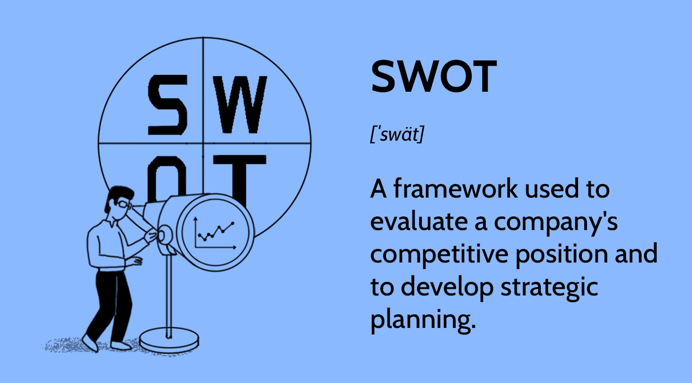

**●Strength:**

1. **Innovative business model:** The Family Pet Doctor App provides a brand new business model, which can provide pet medical services for pet owners on mobile phones
2. **Convenience:** The Family Pet Doctor App provides convenient services for pet owners. Users can make appointments, pay and consult on their mobile phones, saving time and energy. It also solves pet owners' problems, such as waiting in line and inconvenient transportation. And solved pet owners' problems, such as waiting in line, inconvenient transportation, etc.
3. **Market demand:** The pet market is a growing market. With the increasing number of pet consumers, the family pet doctor App will be able to meet this demand and gain more users.

**●Weakness**

1. **Fierce competition:** With the improvement of people's life quality, the competition in the pet medical market will become increasingly fierce. Therefore, the family pet doctor App needs to develop an effective marketing strategy to attract more users.
2. **Dependent on suppliers:** The Family Pet Doctor App needs to establish a good relationship with suppliers to ensure the provision of high-quality pet medical services.

**●Opportunity**

1. **Growing market size:** With the increasing demand and attention for pets, the pet medical market will continue to grow, providing more opportunities for family pet doctor apps.
2. **Trend of change:** Digitalization, mobility and intellectualization are the trends of today's society, which provides more opportunities for family pet doctor App to meet the needs of consumers.

**●Threat**

1. **Policies and regulations:** The pet medical industry is regulated by policies and regulations, and family pet doctor App should abide by relevant regulations and regulations, otherwise it may be fined and other penalties.
2. **Network security issues:** The Family Pet Doctor App needs to protect users' privacy and security to prevent hacker attacks, data leakage and other security issues.
3. **Economic environment:** The uncertainty of macroeconomic environment may have an impact on the business and development of family pet doctor App, such as inflation, economic contraction and other factors.

Therefore, if our platform wants to stand out from the industry, it not only needs to establish a good cooperative relationship with suppliers, but also needs to provide high-quality services to customers. Only in this way can we integrate and merge relevant resources to enhance product competitiveness.

**2.1.3 User Persona**

●**Pet owners:** The primary users of the software are pet owners who care about the health and well-being of their pets and are willing to spend money and time on pet care and maintenance.

●**Busy city people:** These people don't have enough time in their busy jobs and lives to go to the hospital or veterinary clinic, but they want to be able to keep abreast of their pets' health and receive professional advice.

●**Novice pet:** These people are not very knowledgeable about pet care and need professional guidance and advice.

●**Veterinary and pet medical practitioners:** The software provides a platform for veterinary and pet medical practitioners to share experiences and knowledge.

**3.Business Operations**

**3.1 Business Model**

According to the business analysis, the business model of our family Doctor student development team will be based on the following three aspects:

●**Signing mode:** We will provide signing service, so that users can get more comprehensive and personalized pet family doctor service, including professional medical knowledge, health management, personalized medical advice, etc. Our sign-up services will be divided into different levels to meet users' different needs and budgets.

●**Advertising and promotional income:** We will display advertising and sponsor promotional information in our Pet Family Doctor App to generate income. Our advertising and promotion will be targeted according to the interests and needs of users, in order to improve the effect of advertising and promotion and user experience.

●**Intermediary service model:** We may introduce pet insurance, family doctor visits and other services. The platform generates revenue through agency fees.

**3.2 Marketing Strategie**

**Marketing channels**

Our family doctor student development team will likely use the following channels to promote and market our App:

●Social media: We will promote our App through social media platforms such as WeChat, Weibo, BilliBili, etc.

●**Cooperation with relevant organizations:** expand our expertise and influence through cooperation with veterinary schools and pet hospitals. We can provide internship platform for schools and publicity means for pet hospitals. They also bring us flow and users.

●**Media coverage:** We will actively seek media coverage and publicity to expand our visibility and influence.

●**Public relations activities:** We will organize some public relations activities, such as health lectures, medical health forums, etc., to improve our brand awareness and user participation.

Through the combined use of the above marketing channels, we believe that we can effectively promote our family doctor student App and increase the number of users and income.

1. **App Validation**
   1. **Key tests and principles**

●Apps that require users to sign in have a sign-out option.

●No app can download an executable file.

●Apps are tested to not contain ads, promotion for other apps.

●Apps are tested to be work appropriate with no offensive language, cyber-attack bots, spam, or scam content.

●All links in an app are functional and related only to the app offering.

●We test and evaluate our app regularly as part of health checks.